Planet Nine
and the Mass of the Solar System
A companion note to the Tzolkin clock · October 2026

1. Is all the mass in the Solar System accounted for?
Nearly all of it. The mass that moves the Sun and planets is measured to very high precision, and nothing large is missing from the inner Solar System. What remains uncertain is a small amount of mass far out, and whether one more planet exists.
Component | Share of the Solar System’s mass
Sun | about 99.86%
Planets | about 0.135% (Jupiter about 71% of that, Saturn about 21%)
Moons | about 0.00005%
Asteroid belt | about 4% of our Moon’s mass; half of it in Ceres, Vesta, Pallas and Hygiea
Kuiper belt | roughly 0.01–0.1 Earth masses
Dust and the interplanetary medium | negligible

Modern planetary ephemerides, such as NASA’s DE440 and France’s INPOP, track the planets and spacecraft to within metres. They include the Sun, the planets and their moons, a few hundred of the largest asteroids individually, and a ring standing in for the Kuiper belt. They fit the measurements without any extra unseen mass.

What is still uncertain
- The Oort cloud: a vast shell of icy bodies thousands to 100,000 AU out. Its total mass is estimated at anywhere from 1 to 100 Earth masses. It is too distant and spread out to pull measurably on the planets, so it is inferred from long-period comets.
- Planet Nine: a proposed planet of roughly 5–10 Earth masses, a few hundred AU away. It is suggested by the orbits of distant Kuiper belt objects but has not been seen.
- Small, faint bodies: most Kuiper belt and scattered-disk objects are too faint to see, so their total mass is estimated statistically.
- Dark matter: the planets’ motions limit any dark matter inside Saturn’s orbit to less than about one ten-billionth of the Sun’s mass, as expected for dark matter spread thinly through the Galaxy.
The mass is also changing slowly. The Sun turns about 4.2 million tonnes of mass into light every second, and the solar wind carries off about another 1.5 million tonnes. Over billions of years this very slowly widens the planets’ orbits.

2. How Planet Nine was predicted
Neptune was found in 1846 by working backwards from small tugs on the orbit of Uranus. Planet Nine is inferred differently: from a pattern in the orbits of the most distant Kuiper belt objects, bodies that never come near Neptune.
- 2014, Trujillo and Sheppard: after finding 2012 VP113, an object even more remote than Sedna, they noticed that the most distant objects reach their closest point to the Sun near where they cross the plane of the planets, all coming upward through it.
- 2016, Batygin and Brown (Caltech): about six objects that swing beyond 250 AU but never come closer than about 30 AU, so Neptune cannot steer them, have elongated orbits pointing the same way and tilted the same way. The chance of this happening randomly was estimated at roughly 1 in 10,000 to 1 in 15,000. Without some force holding them together, the planets would smear the orbits apart within a few hundred million years.
- Computer simulations: a distant, massive planet on a tilted, elongated orbit pointing the opposite way would herd these objects into exactly this alignment and keep them there.
- A prediction that came true: the model also predicted a second population of objects orbiting nearly perpendicular to the planets, and several were later found.
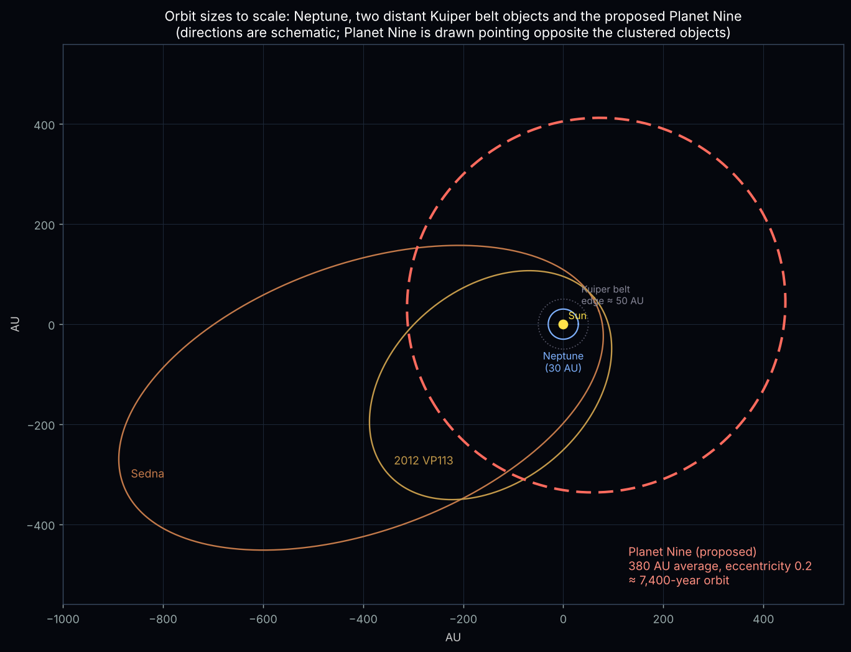
Figure 1. Orbit sizes to scale: Neptune, Sedna, 2012 VP113 and the proposed Planet Nine. Directions are schematic.

Why it is still debated
- Few objects: the pattern rests on only about a dozen well-measured bodies.
- Survey bias: each telescope survey looks at certain parts of the sky at certain times of year. Some astronomers, including the OSSOS survey team, argue this alone could make orbits look clustered.
- Other explanations: the combined gravity of a massive disk of small icy bodies might produce the alignment. A more exotic idea is a planet-mass object that is not a normal planet, such as a tiny primordial black hole.
- No sighting yet: at 400 AU or more, a planet of this size would be very faint, around magnitude 22. Spacecraft tracking, especially of Cassini at Saturn, already rules out many parts of the sky. The Vera Rubin Observatory’s survey, now under way, should either find it or rule out most of the places it could be.

3. How long would its year be?
Kepler’s third law gives the period directly: in years, it is the average distance in AU raised to the power 1.5. The planet’s own mass is too small to matter.
Average distance (semi-major axis) | Orbital period
300 AU | about 5,200 years
380 AU (Brown & Batygin 2021 best estimate) | about 7,400 years
400 AU | about 8,000 years
500 AU | about 11,200 years
600 AU | about 14,700 years
700 AU | about 18,500 years
800 AU (upper end of the 2016 estimate) | about 22,600 years

The 2021 estimate is about 6 Earth masses at 380 AU (range roughly 300–520 AU), with an eccentricity near 0.2 and a 16° tilt. That gives a period of about 5,000–12,000 years, most likely about 7,400 years.
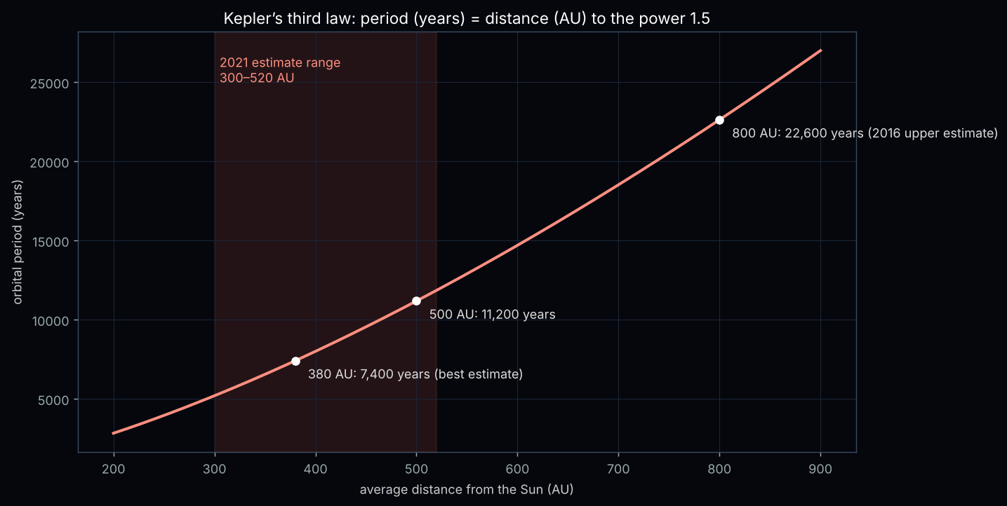
Figure 2. Orbital period against average distance from the Sun, with the 2021 estimate range shaded.

What it would look like from Earth
- Speed on the sky: about 3 arcminutes a year along its orbit. That is faster than Sirius’s proper motion of 1.3 arcseconds a year, but still a crawl.
- Yearly loop: Earth’s own motion would add a back-and-forth loop about 9 arcminutes wide each year, a quarter of the Moon’s width, with months of apparent backward (retrograde) motion.
- Synodic period: it would return to opposition about every 365.30 days, only about 1¼ hours longer than a year, because it barely moves between oppositions.
- Uneven speed: with an eccentricity of about 0.2, its distance would swing between roughly 300 and 460 AU, and it would move about twice as fast near its closest point as near its farthest.
One Planet Nine orbit would take about as long as all of recorded history plus the time back to the first farming villages.

4. Sources
- Trujillo, C. A. & Sheppard, S. S. (2014), Nature 507, 471: discovery of 2012 VP113 and the clustering of distant orbits.
- Batygin, K. & Brown, M. E. (2016), Astronomical Journal 151, 22: evidence for a distant giant planet.
- Brown, M. E. & Batygin, K. (2021), Astronomical Journal 162, 219: updated orbit and mass estimate.
- Planetary ephemerides DE440 (NASA JPL) and INPOP (IMCCE); Pitjev & Pitjeva on dark matter limits in the Solar System.

